
Course Code: | CSA-0313 | Course Title: | DATA STRUCTURE
CO Assessed: | CO1 | Assessment: | ASSESSMENT TOOL 3 - Technical Presentation
Weightage: | 40% | Total Marks: | 25
CO1 Statement: | Apply suitable data structures and ADTs for efficient problem solving by analyzing time and space complexity. (BL3, BL4)
Student Name: | J. BRAHMAIAH | Reg.No.: | 192472286
Department: | CSE -AI | Date: | 15-07-2026
Code of Conduct:
I J. BRAHMAIAH(192472286) certify that this submission is my original work and that I have adhered to the guidelines specified for this assessment. I understand that any violation of academic integrity rules will result in disciplinary action.
J.BRAHMAIAH
Signature of the student:

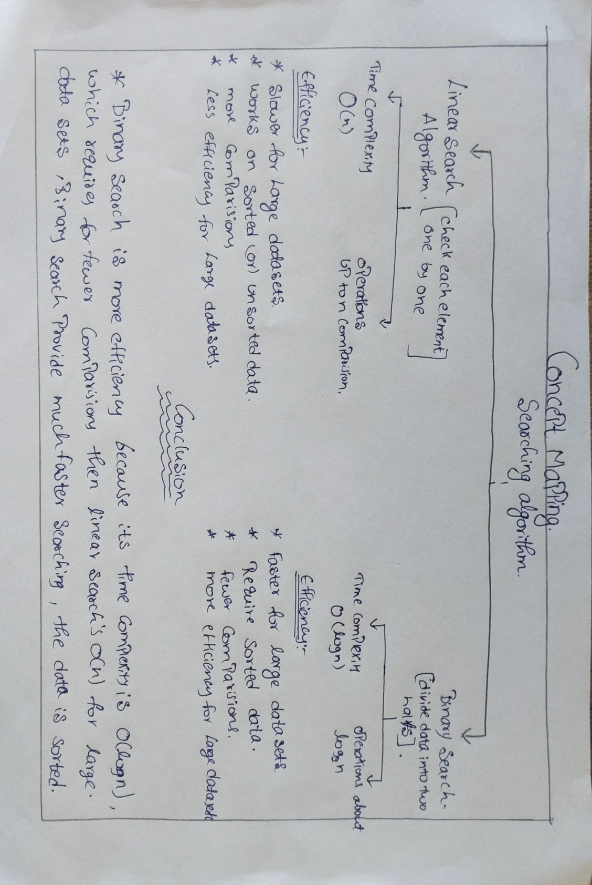

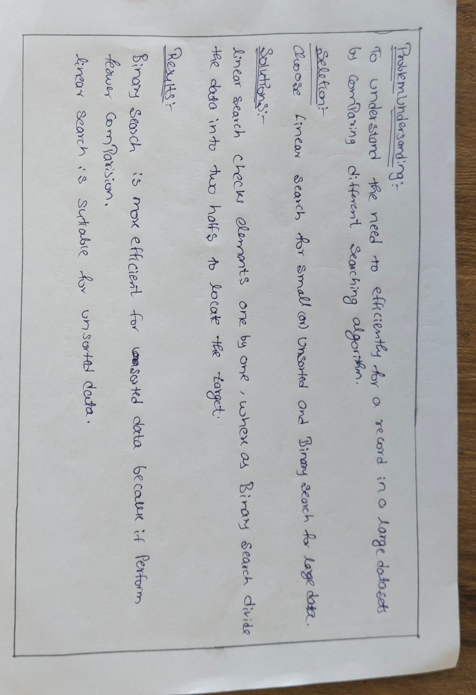

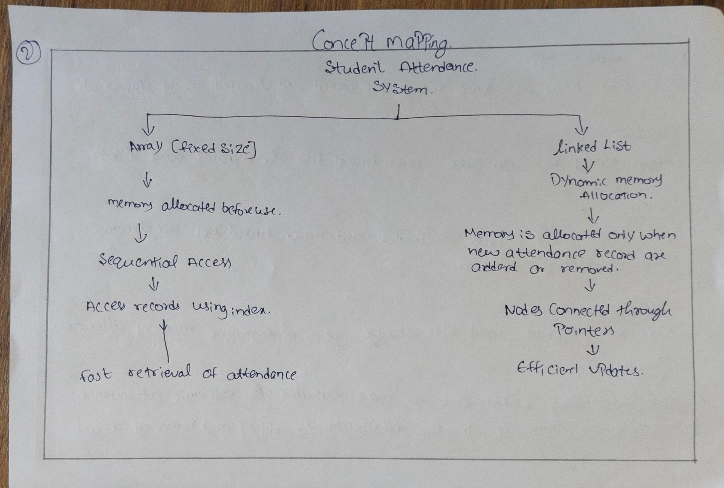

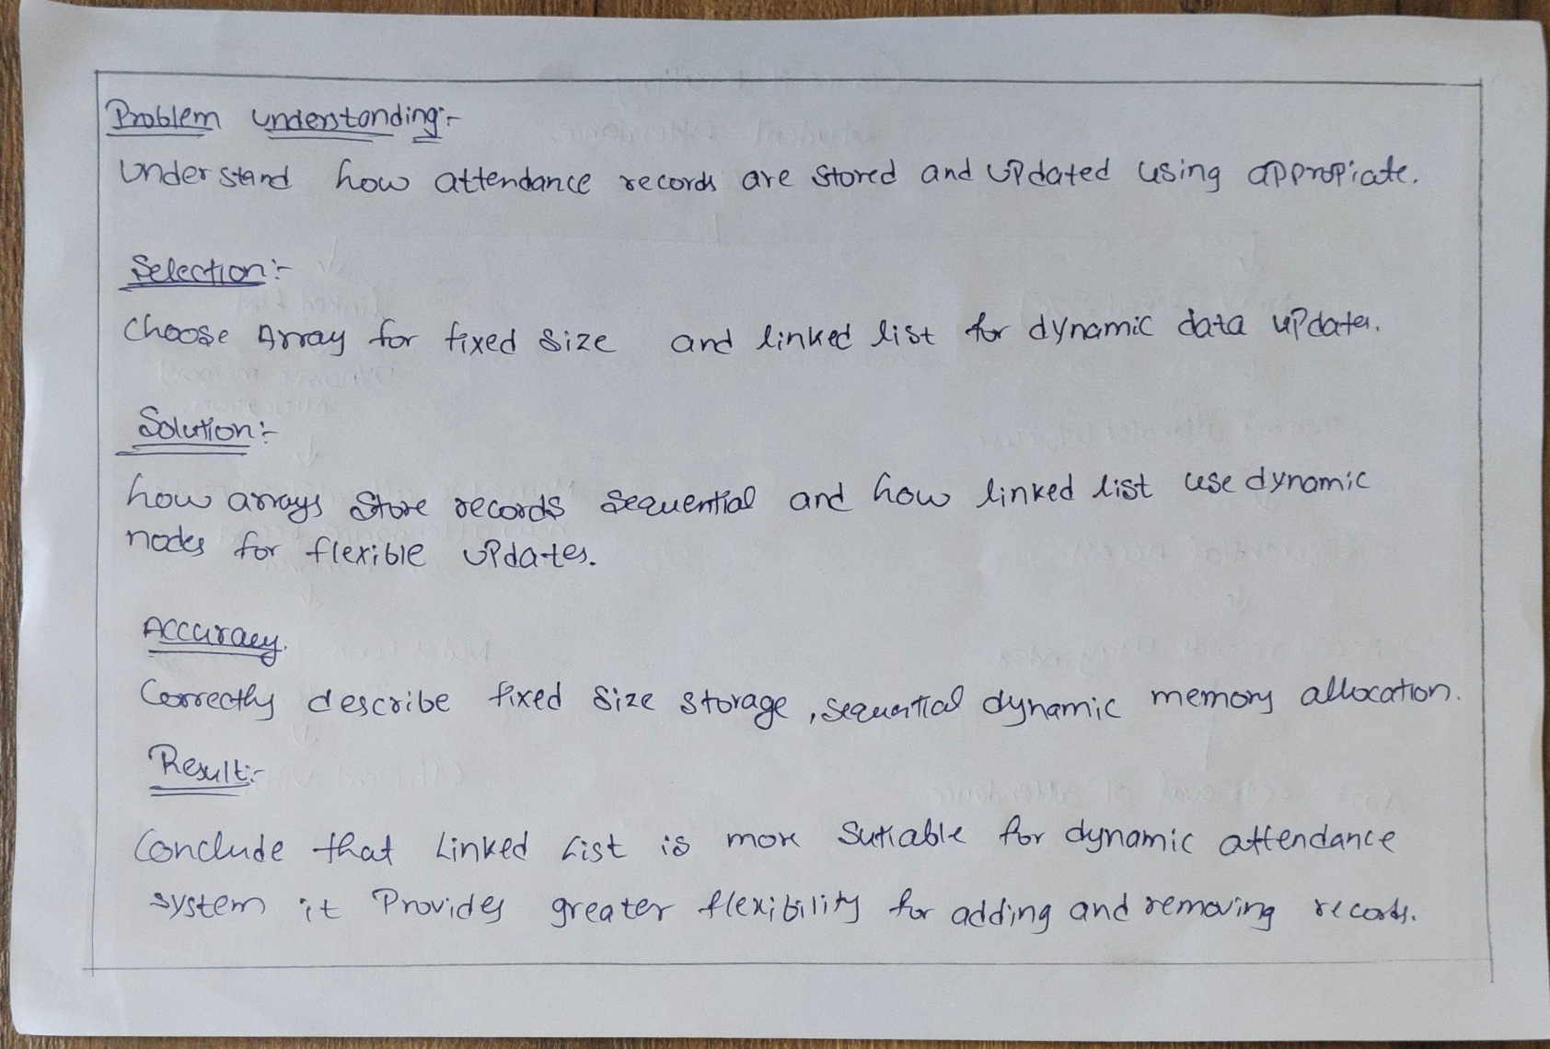
Criteria | Weightage | Level 4 – Exemplary | Level 3 – Proficient | Level 2 – Developing | Level 1 – Beginning
Technical Content Accuracy | 30 | Highly accurate, in-depth, and insightful technical explanation | Technically correct content with adequate depth and clarity | Basic concepts presented with limited accuracy and depth | Content contains major technical errors; concepts poorly understood
Problem Identification | 25 | Problem rigorously analyzed using appropriate and advanced methods | Problem clearly defined with a logical engineering approach | Problem identified but analysis or methodology is weak | Problem statement unclear or incorrect; no logical approach
Use of Tools | 20 | Advanced tools, well-analyzed data, and highly effective visuals | Appropriate tools and data used effectively with clear visuals | Limited use of tools and basic data interpretation | Minimal or incorrect use of tools and data; poor visuals
Communication | 15 | Highly engaging, confident, and audience-focused delivery | Clear, organized, and professional communication | Understandable but lacks clarity, structure, or confidence | Poor organization, unclear speech, ineffective slides
Professionalism | 10 | Exemplary professionalism, leadership, and ethical awareness | Professional conduct with effective team collaboration | Basic professionalism; uneven team participation | Lacks professionalism; minimal contribution or ethical awareness
RUBRICS FOR CALCULATION:

